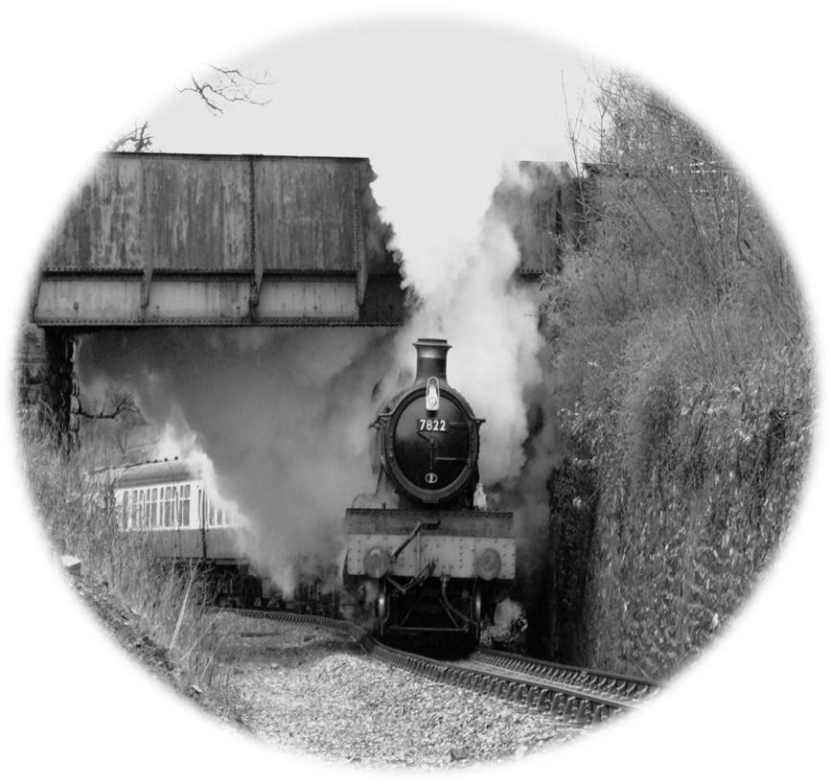

Foxcote Manor Society. Registered Charity Number 1053410
www.foxcotemanorsociety.co.uk
Front Cover Photo : Des Ainsworth Rear Cover Photo : Adie Taylor

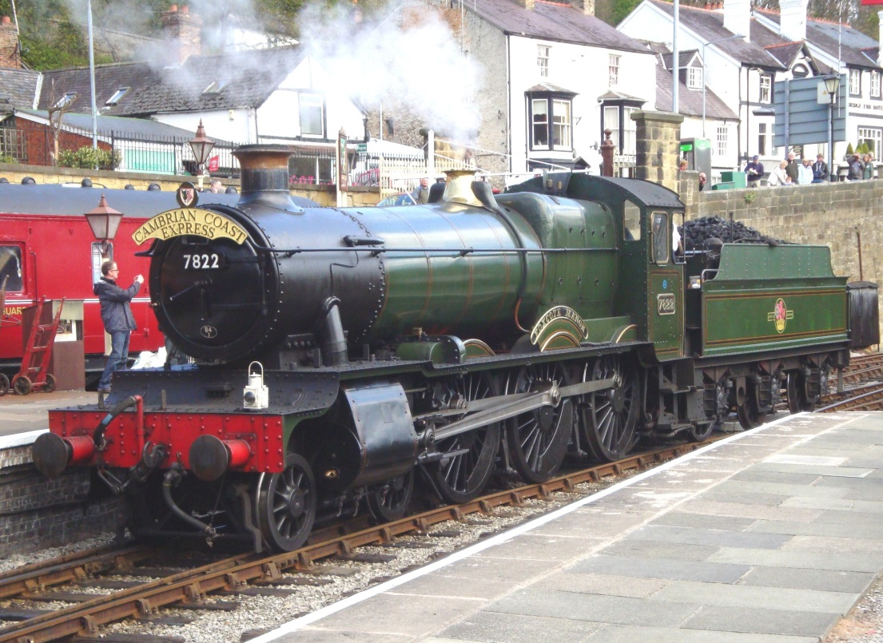

FOXCOTE 7822 CLUB
7822 Foxcote Manor was built by British Railways (WR) in 1950 to a design by Charles Collett of the Great Western Railway.
Having worked from Oswestry Chester and Shrewsbury depots which covered the Cambrian and many other Welsh lines, she was withdrawn from service in November 1965.
The Foxcote Manor Society was formed in 1972 to purchase the locomotive from Woodham Brothers scrapyard in Barry, South Wales.
Restoration work on 7822 commenced at Oswestry in 1975, then after a move to Llangollen she returned to steam in 1988.
Since the initial purchase and restoration by the Society, Foxcote Manor has been overhauled three times. These works have included a new tank for the tender, new tyres fitted to both locomotive and tender as well as major and expensive boiler repairs.
The Foxcote Manor Society has now owned and maintained 7822 for over 40 years, and with your support will continue to do so for many years to come.
HOW YOU CAN HELP
To help us keep 7822 running well into the future, we are inviting you to join the 7822 Foxcote Manor Club. By contributing £10.00 per month (or more if you wish), you will be ensuring that 7822 will keep running primarily on the Llangollen Railway which is a part of the Ruabon to Barmouth route where she regularly worked all those years ago.
If you are a Tax Payer, your donations can be increased by a further 20% Gift Aid contribution from H M Revenue and Customs. Please tick the box on the application form.
The benefits a 7822 Club Member will receive include:
- Periodic News Letters keeping you up to date on what is happening with Foxcote Manor.
- Each year you will receive at least one free ticket to a Foxcote Manor Social Event
- Discounted admission tickets to other Foxcote Manor special events.

To join the Foxcote 7822 Club, please complete the application form on the opposite page. If you wish to volunteer to help the Foxcote Manor Society, please tick the box at the foot of the application form.
Your support is greatly appreciated by the Foxcote Manor Society.

Foxcote 7822 Club Application
PLEASE COMPLETE AND SEND TO :
FMS Treasurer, c/o ‘Llys-y-Fron’, 4 Ffordd Tan’r Allt, ABERGELE, Sir Conwy. LL22 7DQ
I wish to join the Foxcote 7822 Club and agree to pay the following amount by standing order each month.
Name: ( Block Capitals)………………………………...……………...................................................................................
Address: ……………………………………………………………………………………………………….................................................
………………………………………………………………………………………………….......... Postcode:........................................
Telephone number…………………………………………...... Mobile Number: ..….........................……………….....….
E-Mail Address .....…………………………………………………………………………...............................................................
Gift Aid Declaration please tick the box to allow us to claim the tax paid on your donations
I confirm that I pay an amount equal to or greater than these donations in Income and or Capital gains Tax.
Signed……………………………………………………….. Date…………………………………………….
Data Protection Act Foxcote Manor Society is registered under the Data Protection Act. We do not pass personal data to any other organisations, but would wish to keep you informed of the Society’s activitities.
If you do not wish to receive this information, please tick the box.
STANDING ORDER MANDATE

To…………………………………………………………………………...………Bank /BuildingSociety

Branch……............………………………………………………………………………………………………

Branch Address………………….................................. Post Code……………………………..

Sort Code __ __ __ Account Number __ __ __ __ __ __ __ __ __

Account Name…………………………………………………………………………………………………………………….

On 1st Day of ………………………(month) ………………………………(year)
Please pay the sum of £______ (minimum £10)

Amount in words……………………………………………………………………………………………………………….
and thereafter make like payments on the 1st Day of each suceeding month until further notice to:
Foxcote 7822 Club, Barclays Bank plc, Winsford Branch, Cheshire.
Sort Code 20 – 24 – 09 Account Number: 20288527

Signed……………………………………………………….. Date……………………………….

